Global Finance Studies in Belgium 2023
Syllabus

Courses and Credits

Students will enroll in:
9 MSU credits (MSU tuition rate applies)
Here are the credits earned depending on your MSU rising status:
Junior | Senior | Course # | Course Description | Instructor | Credits
√ | √ | IBUS393/FRN491¹²³⁷ | French Business Culture and Language | Olsen | 3 cr.
√ | √ | FI491²³⁴ | Independent Studies | Tessmer | 3 cr.
√ |  | FI311⁵/320⁶ | Financial Management | Tessmer | 3 cr.
 | √ | FI451³⁴⁸ | International Financial Management | Tessmer | 3 cr.
1 This is a mandatory course to participate in the program
2 This course can fulfill the Business Core “International Experience” requirement for all business majors (pre-approval needed)
3 This course fulfills credits towards the International Business minor (pre-approval needed)
4 This course can be taken as a Finance elective by Finance majors
5 This course is a Business Core requirement
6 This course is required for certain non-business degree majors
7 This course can fulfill credits towards the French minor
8 This course can fulfill the Business Core “International Experience” requirement for non-Finance majors (pre-approval needed)

Contact hours:
This is a 9-credit program, offered in accelerated format with three components:
- Introductory group sessions (end of SS23)
- Online sessions (Summer 1 2023),
- a face-to-face education abroad experience of 4 weeks in Namur, Belgium (July 8, 2023 to August 5, 2023).
The number of hours per week that you can expect to spend on each course will vary with the weekly coursework, as well as your study style and preferences. You should expect spending around 15 hours per week to cover readings, take part to online class activities, and complete assignments, during summer 1.

Faculty leaders

Antoinette Tessmer
Program Director
Associate Professor of Finance
MSU Broad College of Business, Finance
FI311/FI320, and FI451

Hannah Olsen
Program Co-Director
PhD candidate
MSU College of Arts and Letters, French
IBUS393/FR491

Alexandre Girard
Guest faculty
Assistant Professor of Finance
Université Saint-Louis, Brussels, Belgium
FI491

Disclaimer
This syllabus and the schedule, policies, and assignments contained in this document, D2L, or Loncapa are subject to change in the event of extenuating circumstances, class progress, and opportunities for guest lectures or site visits, at the discretion of the faculty leaders, upon advance notice to the students. The material included in this document is meant to provide an outline of the course and rules that the faculty leaders will adhere to in the evaluation of the student’s progress. This is a statement of the instructions, rules, and policies that must be followed by program participants. Questions regarding the syllabus are welcome at any time.

Overview
Consider this syllabus as a roadmap for your study abroad experience. Please read through its content carefully before continuing in this program and ask questions if you would like anything clarifies. The established policies and expectations are intended to create a productive learning experience for all students. Unless you are prepared to abide by these policies and expectations, you risk losing the opportunity to further participating in and completing the program. This syllabus also serves as a notice to each student regarding course requirements and student obligations. Keep this document as a reference.

Overall Program Goals
This short-term education abroad program seeks to help students:

- Gain an understanding of the French language, French/Belgian culture, and European business culture.
- Enhance their ability to interact with cultural differences on a personal and professional level.
- Challenge, understand, and appreciate their culture and experiences and how these influence their world views.
- Understand the meaning of citizenship as it relates to one’s personal and professional influence on local, national, and global issues.
- Develop their understanding of the European financial system.
- Develop their appreciation of the extent to which a wide variety of global effects affect business decision-making, both domestically and globally.
- Enhance their critical, creative, reflective thinking and problem-solving skills by applying major principles of finance to diverse business situations.
- Develop and demonstrate their oral and written communication skills through daily participation and through assignments and examinations that require research, analyses, and written responses.
In addition to the overall program goals, by contributing to a service project and participating in company and site visits, students will be able to:
- Develop an increased awareness and sensitivity to diverse cultural environments.
- Utilize a culturally sensitive approach to the care of individuals and communities.
- Demonstrate professionalism and respect within the role of student business professional.
- Utilize effective communication with respect and cultural sensitivity.
- Foster respect for diverse viewpoints.
- Demonstrate collaboration with community leaders and members to provide care and understanding to the community.
- Gain understanding of the impact of globalization on business and society.
- Demonstrate an understanding of a set of cultural values and beliefs other than their own.
- Foster awareness of what our personal and collective responsibilities are toward being global citizens and business professionals.
- Integrate the study of foreign language with discipline-based content
- Demonstrate an awareness of international career and study opportunities in government, business, education, and in organizations servicing international concerns.

Namur, Belgium

Namur is the capital of Namur province as well as the political capital of Wallonia (the French-speaking, Southern part of Belgium). The city has a population of 100,000. Namur is located at the confluence of the Sambre River and the Meuse River (both major waterways), and thus has had a military significance in centuries past that caused frequent conflicts, from Roman times through WWII. Namur will be your Belgian home away from home for four weeks! The University of Namur (UN) is located downtown Namur.
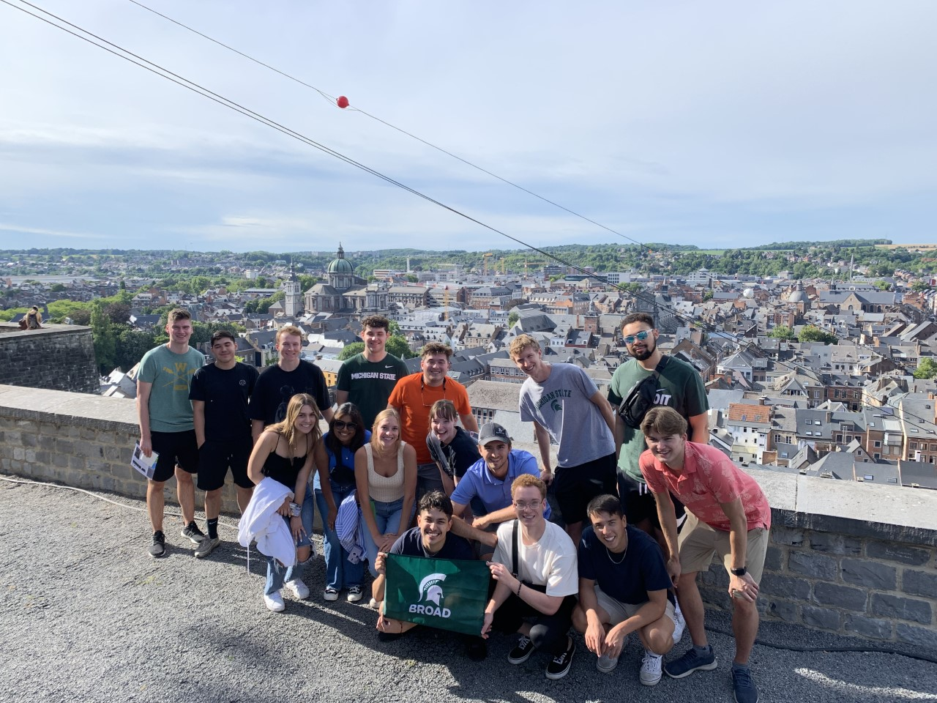

Promotional video: https://youtu.be/fDrsb13oAhY
Follow us on Facebook: www.facebook.com/groups/245680812190468
Follow us on Instagram: MSUgfs or www.instagram.com/msugfs

Course Descriptions and Learning Goals
FI311/320-Financial Management (3 credits)
Description
Financial Management is an introductory course serving students who wish to pursue their studies and career in corporate finance or in financial market investments. The course covers fundamentals of finance used by practitioners on Wall Street and in corporate America. Risk and return measurements and analyses will be performed based on financial information and using Excel models such as discounting cash flows for capital budgeting, and valuation of treasury, corporate bonds, and common stock. Additional topics include, but are not limited to, time value of money, corporate capital structure, capital budgeting, working capital management, investment analysis, and valuation.

Students will be exposed to financial modeling using Microsoft Excel. A laptop should be brought to class with a running version of Excel 16.

Learning Goals
After successfully completing this course, students should:
- know the functions of financial professionals and the finance department in a corporate setting
- understand Time Value of Money and how it impacts corporate and personal financial decisions
- know the basics of stocks and bonds, and their implications in both corporate and personal finance
- understand how corporate capital spending decisions are made
- understand the relationship between risk and return
- have a better understanding of how to use Microsoft Excel

Course Materials and Topics
Course platform:
D2L
Textbook:
Antoinette Tessmer, Financial Management, ISBN# 9781307405682
Ebook available at https://create.mheducation.com/shop/#/catalog/details/?isbn=9781307405682 (~$74)
Topics:
Chapter 1&2: Introduction to Corporate Finance
Chapter 3: Financial Statement Analysis and Modeling
Chapter 4: Time Value of Money
Chapter 5: Interest Rate and Bond Valuation
Chapter 6: Stock Valuation
Chapter 7: Net Present Value and Other Investment Decisions
Chapter 8: Making Capital Investment Decisions
Chapter10: Risk and Return: Lessons from Market History
Chapter 11: The Capital Asset Pricing Model
FI451-International Financial Management (3 credits)
Description
This is a discussion-based course that will study the challenges of making informed personal and corporate financial decisions in a global environment. We will practice the mathematics of exchange rates and international parity conditions. Whether for arbitrage or hedging purposes, foreign currency futures, option, and Swap contracts will be studied as fundamental contributors to a more stable and reliable global financial environment. Special elements of risk taken in global financial positions will be discussed at the country level and at the corporate capital budgeting level.

Learning Goals
After successfully completing this course, participants will be able to:
- Develop and execute financial strategies in more than one national business environment
- effectively work within the constraints imposed by host cultures and governments
- Identify, measure, and manage exposures to country and currency risks
- Understand the expected returns and risks of international financial assets and liabilities
- Make informed investment and financing decisions in international financial markets

Course Materials and Topics
Course platform:
D2L
Textbook:
K. Butler, Multinational Finance – 5th Edition
Log in in with your MSU id should be able to download the text (for free) at this URL.
https://onlinelibrary-wiley-com.proxy2.cl.msu.edu/doi/book/10.1002/9781119219729
Topics:
Chapter 3: Foreign Exchange and Eurocurrency Markets
Chapter 4: The International parity Conditions and their Consequences
Chapter 5: Currency Futures and Futures Markets
Chapter 6: Currency Options an Options Markets
Chapter 7: Currency Swaps and Swaps Markets
Chapter 9: Managing Transaction Exposure to Currency Risk
Chapter 12: Foreign Market Entry and Country Risk Management
Chapter 13: Multinational Capital Budgeting
Chapter 14: Multinational Capital Structure and Cost of capital
Chapter 19: International Portfolio Diversification

FI491-Special Topics in Finance (3 credits) - Tentative
Description
This course will propose two separate activities:
- A portfolio management simulation
- An extensive individual research, investigation, and writing to complete a study document that will be the topic of an onsite class presentation. Study topic(s) will be agreed upon before the start of summer 1 2023.
Learning Goals
Students will gain knowledge about a selected international financial topic that will be studied in the American and European context.
After successfully completing this course, students will be able to:
- Explain the topic in clear and succinct terms
- Compare and contrast the topic in the European and American contexts
- Make an informed and documented presentation of the topic
- Respond to questions about the topic raised by their classmates

Course Materials and Topics
Possible topics:
- Local currencies
- Sustainable finance
- The role of a central bank
- History of the Euro currency and its current role in the global economy

IBUS393/FR491-French Business Culture and Language (3 credits)
Description
This course will introduce students to the French language and the European Francophone business culture in preparation for their education abroad experience in Belgium.
Learning Goals
After successfully completing this course, participants will be able to:
- Speak basic French including introducing themselves and where they are from, asking and responding to simple yes-no questions, asking for directions*
- Recognize and understand basic French vocabulary related to everyday life in a Francophone community (including but not limited to grocery shopping, travel, going to the laundromat, leisure activities etc.) *
- Objectively analyze various dimensions of a culture that can influence one’s perspective in a business context, specifically they will be familiar with appropriate cultural norms in formal, Western European settings
- Understand the importance of Belgian history, specifically the social, political, economic, and linguistic history of the country and its three main regions. Students will be able to recognize these cultural complexities in other cultures as well
- Efficiently participate, in an autonomous manner, in a service project for a local non-profit organization.
*French minors will not be expected to repeat basic speaking and reading skills in French, rather, they will be expected to complete the other course Learning Goals in French.
Course Materials and Topics
Course platform:
D2L
Textbook:
“Getting Started in French with Audio CD: A Teach Yourself Program” by Catrine Carpenter
Topics:
Spring Module 1: Introductions and Regions of Belgium
Spring Module 2: Food, numbers 1-20 and History of Belgium
Spring Module 3: Simple Response Questions and the European Union
Spring Module 4: Weekly Schedules and Work-Life Balance in Belgium
Spring Module 5: Cardinal Directions and Travel in Europe
Summer Module 1: Review of Basics and Language and Culture
Summer Module 2: Food and Environment of a Culture
Summer Module 3: Lodging and Social Organization
Summer Module 4: Manners and Cultural Context
Summer Module 5: Cultural Attractions and Authority
Summer Module 6: Numbers 20-100 and Nonverbal Communication
Summer Module 7: Asking for Directions and Time
Belgium Module 1-4: Community Service and Non-Profit Organizations in Belgium and in Europe

Course Schedule

Pre-departure (subject to changes)
June 2023
From May 15th to June 30th, we will hold weekly synchronous sessions and deliver online material for all four courses.

On site (subject to changes)

First Sunday in Namur, Belgium (July 9, 2023)
Outdoor team building day (paintball, bridges, ziplines, team building activities)

Weekly schedule
Monday
10am-12noon Petit Dejeuner & Service project or FI311 class session
1-2pm IBUS393 class session
3-5pm Service project or FI451 class session
Tuesday
10am-12noon Petit Dejeuner & Service project or FI451 class session
1-2pm IBUS393 class session
3-5pm Service project or FI311 class session
5-6pm Help room (HW due by midnight)
Wednesday
10am-12noon Petit Dejeuner & Service project or FI311 class session
1-2pm IBUS393 class session
3-5pm Service project or FI451 class session
5-7pm Cultural visits (Namur citadelle, Château de Vêves, Snail farm, …)
Thursday
10am-12noon Petit Dejeuner & Service project or FI451 class session
1-2pm IBUS393 class session
3-5pm Service project or FI311 class session
5-6pm Briefing on Friday trip
6-7pm Help room (HW due by midnight)
Friday field trip
Brussels: European parliament, The Belgian Central bank, NewB, chocolate workshop
Luxembourg: The European Investment Bank, ParisBas
Antwerp: Diamond industry, Fashion museum
Strasbourg, France: The European parliament

Weekends are open for personal activities in Namur and/or group visits in/outside Belgium

General Student Expectations
You are enrolled in an institution of higher learning and your enrollment in this education abroad program is evidence that you have successfully navigated your way through a preliminary college education. As such, we have high expectations concerning your attitude and behavior in this program and diligence is expected. We assume that each of you is a responsible, thinking adult who wants to do their best. We also believe that each of you has knowledge and creative ideas that are valuable and that should be shared. Given these beliefs, we expect that each of you will be an active, intelligent, and mature participant in and out of the classroom.

Participation and Attendance

Attendance and Tardiness
Class discussion is an integral part of the learning process in this program. Therefore, class participation is a factor in your grade. Absenteeism or lack of preparation will adversely affect your grade. In a traditional class environment, regular and punctual class attendance is expected along with class participation because those are essential to student success. Since each course in the program will run as a discussion-based seminar, every student’s careful preparation, attendance and active participation is essential for their success. Therefore, to ensure the commitment to student success, attendance is required (mandatory) in all scheduled elements of this program.

Considering that the courses in this program are taught/offered as education abroad courses, a significant portion of the requirements will be completed in a foreign country. Attendance to all meetings, both pre-departure and on site, is mandatory, i.e., each student is required to attend (i) ALL scheduled activities and functions (lectures, seminars, site visits, and field trips) abroad during the four weeks on site and (ii) the on campus pre-departure sessions. Any absence or tardiness must be approved in advance by the faculty in charge. Please note that an unexcused absence in the program is grounds for dismissal from the program.

Participation
Since GFS is likely more intense than you might be used to in a traditional course setting, missing even one lecture can have a proportionally greater effect on your final grade simply because there is little room to make up for lost time. Participation in all components of the program is mandatory because your actions can significantly affect the experience you and your classmates have while on site. Therefore, it is important that you are prompt for all scheduled program activities, complete the necessary exercises, and simply get involved.

For GFS to run successfully and to facilitate constructive informed discussions, readings and assignments must be completed prior to class, which means you must come to class prepared. In addition to completing all of the assigned readings prior to class, you should be prepared to offer original and thoughtful analysis. For each reading, you should be able to summarize the reading, provide relevant commentary, and offer insightful questions to extend discussion of the reading. A discussion with a few classmates prior to class would typically be advised.

Your class contribution will depend on both the quality and quantity of contributions. “Persuasion” and “reasoned opinion” will be valued over simply conversing. During class discussion, you must listen carefully to what other people are saying before responding, and you must consider and evaluate each perspective presented. Whether you are reading an assignment, listening or speaking in class, or writing a paper, you must show not only correct computations but also well-reasoned judgment. Opinions will be relevant only if they are accompanied by a judgment reached through well-reasoned evaluation.

General Classroom and Venue Visit Etiquette
Please come to class on time. Given the amount of material we cover, our time is limited. Your absence from part of the class shortchanges you and your classmates. We will plan to start on time and end on time. This requires that all of us be on time.

As a diverse community of learners, students must strive to work together in a setting of civility, tolerance, and respect for each other and for the instructor. Rules of classroom behavior include, but are not limited to, the following:
- Conflicting opinions among members of a class are to be respected and responded to in a professional manner.
- Side conversations or other distracting behaviors are not to be engaged in during lectures, class discussions or presentations.
- Students are encouraged to show guest speakers courtesy and respect. The guests who are meeting with us are doing us the enormous favor of contributing their experience and insight to our class discussions without any direct compensation from the University. Their primary motivation for doing this is the positive experiences they have had in the past interacting directly with students. You are welcome to pose “challenging” questions to guest speakers, but you are strongly encouraged to do so in a respectful way, recognizing that access of future student generations to these practitioners will be, in part, a function of the quality of their experience in our classroom.
- Likewise, students are expected to show one another similar courtesy and respect during classroom discussions. Students are welcome – indeed, encouraged – to “challenge” one another’s ideas, as well as the positions taken by the instructors. However, students are expected to do so in a way that maintains an atmosphere of civility and mutual respect.
- You should expect that if your conduct during class discussions seriously disrupts the atmosphere of mutual respect we expect in this class, you will not be permitted to participate further.

While you are abroad, you are representing not only yourself, but also Michigan State University and the United States of America (and/or your native country, if it is not the U.S.). Remember that any interaction that you have with the citizens of the country you are visiting can leave a lasting impression, especially if you violate sensibilities. Citizens of every nation are proud of their heritage. Avoid making snide remarks or, even worse, acting in a manner that is insulting to them.

Therefore, when you are abroad, you should strive not just to be aware of cultural differences, but also experience and appreciate them. Try the local foods, even if you do not think you will like them. Eating different foods for a week or two will not terribly harm you. View this as a chance to practice the skills that you might need someday if you become engaged in international business.

During business visits, you should behave in a professional and businesslike manner. Formal business attire is required. Be inquisitive and show your interest in the host company but remain respectful at all times. In general, you should never use familiar forms of address (e.g., first names) unless you are specifically invited to do so.

During field trips, your demeanor should be appropriate at all times and be mindful of other participants and visitors. The bottom line is that you will enjoy the trip more if you are willing to be open-minded and culturally sensitive.

