Website:
At the Russell Palmer Career Management Center, we help Broad international students navigate the career search process by providing support on all aspects of career development, including career advising, career education programming and customized events. In addition, our team focuses on cultivating employment opportunities in the US, home country, and globally. We can help you in your job search both in the US and overseas.
Jump to a section:
- International Student Career Programming
We offer specialized career programming to meet the unique needs of international students throughout the search for internships and full-time career opportunities. International students are encouraged to utilize these resources to expand their pool of job opportunities.
Global Career Networking Series
The Global Career Networking Series (GCNS) is a series of intensive career development and career search programs. GCNS consists of a one-day career bootcamp, where participants learn key career development skills (including resume building, networking strategies and more) in a condensed amount of time; an immigration info session where professionals explain the work authorization and work visa process in the US and other countries; and a Broad international alumni career panel who share their job search, work experiences, and insights. In addition, over 20 globally-renown companies from various regions conduct info sessions regarding job openings, corporate culture, and new hire/student programs. Timeline: Fall
Resume Books
The resume book is a compilation of student resumes that are sent to overseas employers (Fortune 500 companies) seeking to hire Broad students for full-time positions and internships. Our team helps students ensure their resumes are career-ready prior to inclusion in the resume book. The resume book is distributed two to three times a year. Timeline: Fall, Spring, and Summer
Various Recruiting Events including Webinars and On-Campus Company Visits
The Palmer Center facilitates corporate webinars and on-site visits to promote access and opportunities to network with highly-regarded global employers. Timeline: Fall and Spring
Global Openings Resource
The Palmer Center compiles a detailed resource indicating global openings that cover multifaceted industries. This resource is distributed two or three times a year. Timeline: Fall and Spring

International Career Trek
The International Career Trek provides students with opportunities to build networking relationships with Fortune 500 employers and gain insights into their business practices and trends. It also offers the opportunity to experience the corporate culture and careers available in each company. Note: This event is typically in-person but has also been conducted in a virtual format. Timeline: Spring/Summer
Career Advising and Coaching
The Palmer Team offers 1:1 career advising appointments that can cover a variety of different topics including mock interview preparation, resume reviews, and advice on job search strategies. Timeline: Fall, Spring, and Summer

- International Student Career FAQs
We understand that there are various questions facing international students when it comes to the job search. From disclosing visa status to subtle cultural differences in the US job search to finding employment in one’s home country or globally, it can feel overwhelming. Our team has compiled some of the most frequently asked questions to help students begin the job search.

- As an F-1 student, how should I answer work authorization questions during the application process?
In the US, employers are not allowed to ask about a candidate’s age, race/ethnicity, gender, country of origin, religion, disability, or marital/family status. However, employers may ask questions related to work authorization. Common questions could be (wording may vary):
Are you authorized to work in the United States?
Your answer: YES. If you are on an F-1 status and eligible for applying for practical trainings; you may answer YES.
If you are seeking internship and eligible for applying for Current Practical Training (CPT) and if there is space to provide additional information, you should indicate that you will be applying for CPT for the internship which enables you to work in the US without employer sponsorship as long as the position is relevant to your major for these specific dates: from XX to XX.
OR
If you are seeking full-time employment and eligible for applying for Optional Practical Training (OPT): you should mention that you will be applying for OPT (you have already applied) to begin on X date which is an employment benefit that will allow you to work in the US for XX months without employer sponsorship. If you are enrolled in a STEM-designated program, then you can mention you are eligible for the STEM OPT Extension, which is currently 24 months. To continue working beyond this timeframe, your employer would have to file for a work visa for you.
Will you now, or in the future, require sponsorship for an employment visa?
Your Answer: YES, because you will require work authorization once your student immigration status ends.
- When should I disclose my work authorization as an international student to an employer?
There are many approaches to informing an employer. If a question is asked as part of the online application, provide an honest answer. See above-mentioned sample answers. If a question is not part of the application or asked by employer during an interview, it is recommended to briefly mention your work authorization status by the end of the first interview or possibly before the second interview. The strategy is to get familiar with your status and work authorization options and focus more on the strengths that you can offer as an international student rather than visa challenges.
- Why isn’t there an employer list of those who will consider hiring international students?
In essence, this is a great idea, however it is extremely difficult to create and maintain such a list. Many employers are unwilling to disclose this information directly and their policies are often changing which makes a list unsustainable and unreliable. Unfortunately, there is not a single easy way to identify opportunities, thus, a creative strategy is essential to identify eligible opportunities.
- How do I know if employers hire international candidates or how can I find “international friendly” employers?
You may have concerns about whether employers in the US hire international students. Online research and networking can help identity “international friendly” organizations. As you conduct your research, consider the following resources:
Handshake:
Use the Work Authorization filters of the job search and fair search pages of Handshake to identify employers who are willing to provide job visa sponsorship or are accepting international student applications using work authorizations such as OPT and CPT. You will be prompted to answer the following questions related to work authorization when you create your profile and if you do not provide answers to these questions, you will be prompted to answer work authorization questions during your first application in Handshake or if you register for a fair which will then be saved for future applications.

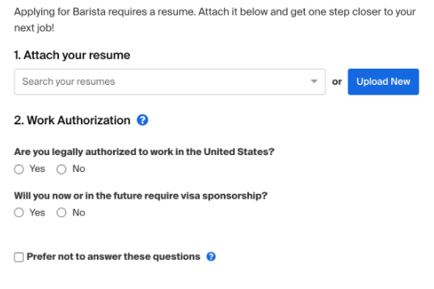

IMPORTANT NOTE: If you select "Prefer not to answer these questions", your information will show as FULLY QUALIFIED for the position and you will be able to view and sign up for virtual fair 1:1 sessions with work authorization requirements. You will be able to see your eligibility for an opportunity in the employer preferences box for each posting. (Examples are below.) It’s important to note that Handshake will not block/prevent you from applying for an opportunity if you do not match a preference.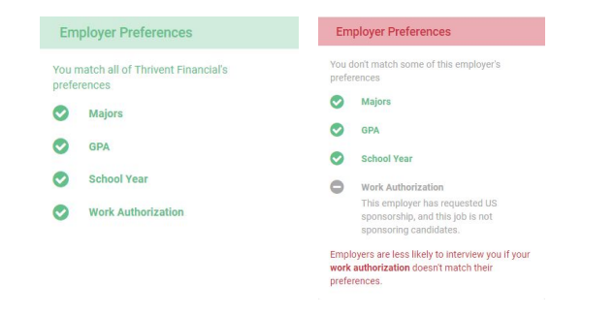

GoinGlobal
GoinGlobal is an online database for searching career opportunities in the US and abroad. It contains information including lists of US employers with past records of H-1B sponsorship activity and provides country career guides and job search resources for more than 120 worldwide locations. It is accessible through MSU Handshake (once logged in, go to Career Center, click Resources, and look for a GoinGLobal link). In addition, GoinGlobal has other helpful features: work permit/visa regulations, resume writing guidelines, employment trends, salary ranges, networking groups and cultural/interviewing advice.

Myvisajobs.com
Myvisajobs.com Is an online platform to identify which US employers have petitioned for a work/H-1B visa in the past. This site also provides names of employers who have sponsored for Permanent Residency (Green Card) including locations and types of positions.

US Department of Labor H-1B Data
The US Department of Labor Office of Foreign Labor Certification generates annual reports on labor certifications, which is a core part of the H-1B and Permanent Residency application process. Report examples include top occupations for H-1B by state, top 10 employers sponsoring H-1B visas and top occupation areas for Permanent Residency applications. If you are applying for the H-1B work visa, you may be interested in researching the trends and patterns for this visa type in your state or industry. The U.S. Department of Labor publishes reports on top occupations for H-1B by state, top employers sponsoring this visa, and best occupation areas for permanent residency applications, among other data.

- What if I am unable to secure a job in the US?
We recognize international students face unique challenges in their job searches due to complex immigration systems. It is critical that you realistically consider a “Plan B” by exploring and conducting multi-country job search in the US, home country, and perhaps other countries to increase the likelihood that you will find employment after graduation. There are various career resources and programming available to help Broad students navigate global job search/career opportunities including: global resume books, networking series, career panel, treks, etc. Plan ahead and stay connected with our team!

- Visa Information (Practical Trainings CPT and OPT)
International students have unique challenges when it comes to a job search in the US. It is important to be knowledgeable about your visa status and to know how to effectively communicate these visa requirements with an employer. International students should respond honestly about their immigration status and work authorization eligibility when asked. Before the job search begins, international students need to learn about work authorization options to facilitate the hiring process for employers. There are two types of off campus work authorizations F-1 international students can apply for: Current Practical Training (CPT) – used for internships or work off-campus during the academic year and Optional Practical Training (OPT) – used for post-graduation employment. All off campus employment must be related to a student’s field of study. For more information, visit https://oiss.isp.msu.edu/immigration1/visa-and-immigration-overview/ If a student has further questions on work authorization options, please consult with a OISS advisor ( https://oiss.isp.msu.edu/ )

- Helpful Resources
Listed below are online resources and databases that may be helpful for international students in researching career opportunities in the US, Asia Pacific, and globally.
US and Multi-country Search:
- My Visa Jobs- Students can search for employers by industry, career, city, and, job title and review reports on H-1B visa submissions
- GoinGlobal – Information on employers who have petitioned for H-1B visas as well as cultural and networking information. It provides country career guides and job search resources for more than 120 worldwide locations and it is accessible through MSU Handshake (once logged in, go to Career Center, click Resources, and locate a GoinGlobal link)
- Global Talent Retention Initiative of Michigan- Lists employers interested in hiring international students, posts available positions, and provides information to employers
- Jobbatical - Job board that connects you with opportunities in the U.S. and all over the world
- Monster Overseas Search - Connects Monster.com users to 51 affiliated job sites in 44 countries
Asia:
- Contact TAIWAN - Website to engage overseas Chinese individuals to work in Taiwan. Contact TAIWAN actively links professionals to support the growth of Taiwan industries, and offers talent friendly service and information
- 51Job.com - Online database with job listings for students who are looking to focus their job search in China
- Zhaopin.com – Chinese job board; all content is in Chinese
- Job Korea – Korean job board which includes part-time, entry-level, and mid-career postings. All content is in Korean
- Career Forum - Website with information about internationally recognized job fairs for Japanese-English bilinguals. Also allows members to search for global job opportunities, apply to companies, and schedule interviews
Europe:
- Jobrapido Connects to multiple job sites in the United Kingdom
- Eurojobs - British job site that markets itself as the “only multi-country job site in Europe
- Jobware - International database of primarily German-based multinational companies.

