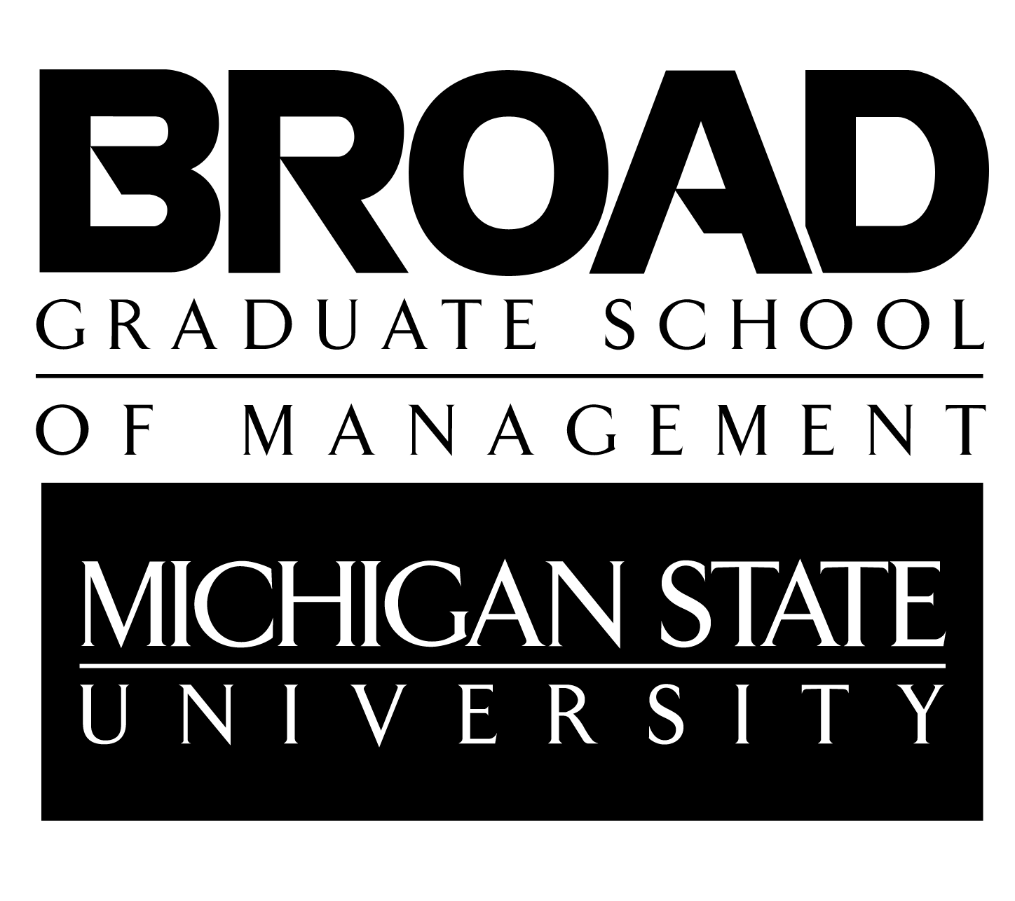
Master of Science in Accounting
Course Scheduling Guide
2022–2023

General Overview

OVERVIEW

- The M.S. in Accounting is a 30-credit STEM Certified degree program. More credits may be needed if prerequisite courses are required if they do not have accounting or business courses. Students must complete at least 12 accounting credits.
- Students are required to elect an accounting specialty option. Specialty options include Information Systems (IS), Public and Corporate Accounting (PCA), Taxation (TAX), and Transaction Services (TS).
- Students must complete at least (9) credits outside of accounting. Per accreditation standards, IS courses can also be considered as non-accounting classes. Thus, a student could choose an option in Public and Corporate Accounting, Taxation, or Transaction Services and Information Systems.
- To schedule an appointment with your academic advisor, please use this link: (http://accounting.broad.msu.edu/welcome/ms/advising/).

Linked Program POLICY

- You must have a dual enrollment form on file.
- You must apply for graduation for your undergraduate degree.
- The courses you wish to count toward your M.S. degree must be listed on the dual enrollment form. Your cumulative credit total must be over 120 credits for them to count. E.g. If you want to use the 3 credits from ACC 411, your credit total must be at least 123.
- If you change a course or do not adhere to the dual-enrollment form, it could result in classes not counting towards your M.S. degree.
- Contact the Director with any questions regarding the linked program or dual enrollment form.

OVERRIDE POLICY:

- You will need to apply for overrides in the following cases before enrollment begins:
  - If you did not complete your undergraduate degree at MSU.
  - If you did not complete the course prerequisites at MSU.
  - If you wish to enroll in any non-accounting courses (e.g., MKT, SCM, FI, MGT, GBL, etc.).
  - If the course is offered outside of the Broad College of Business. You will need to contact the specific department to get an override (EC 420 contact the Economics Department).
  - If you are a graduate student taking a 300- or 400- level course.
  - If you are in the linked program and taking any 800-level course.
  - If any course is beyond the enrollment limit.

- Links for overrides:
- Accounting (ACC), Finance (FI), and General Business & Business Law (GBL): https://uas.broad.msu.edu/advising-student-services/overrides/.
- Supply Chain Management (SCM) & Marketing (MKT) override requests need to be emailed directly to broad.msc.inquiries@msu.edu along with the reason for the request.
- Management (MGT) override requests need to be emailed directly to mgt@msu.edu.
- COM 875 is our course and you should not have to apply for an override (unless you are in the linked program and still an undergraduate or it is at the enrollment limit-contact the Director for further instructions).
- All courses that are not in the Broad Business College, you will need to contact that department for an override.

Specialty Option Requirements

Students must select one of the following options and enroll in the required courses. Priority for courses will be given to those within the specialty option(s). All courses are 3 credits each.

- Information Systems (IS) Option
MSU undergraduate accounting majors: Pick (4) of these courses-ACC 822, ACC 823, ACC 824, ACC 825,
ACC 826
External accounting majors: ACC 821 and pick (3) of these courses- ACC 822, ACC 823, ACC 824, ACC 825, ACC 826
Required Course: COM 875 & ACC 827

- Public and Corporate Accounting (PCA) Option
Pick (4) of these courses-ACC 807, ACC 808, ACC 814, ACC 833, ACC 841, ACC 843, ACC 850
Required Courses: COM 875, FI 801, & ACC 827

- Taxation (TAX) Option
These courses- ACC 830, ACC 833, ACC 836, ACC 850
Required Courses: COM 875, FI 801, & ACC 827

- Transaction Services (TS) Option
These courses- ACC 807, ACC 850, ACC 891, FI 845/846
Required Courses: COM 875, FI 801*, & ACC 827
*This course must be completed if you do not have FI 311 and 312 in your undergraduate.

SCHEDULING ADVICE

- Taxation (TAX) Option suggestions:
  - ACC 833 and 836 may be taken concurrently.

- Information Systems (IS) Option suggestions:
  - Only (4) of the (6) courses are required for this specialty.
  - For a solid technical core, the faculty recommends ACC 823, 825, & 826.
  - External accounting majors wanting to complete their M.S. in one year should take ACC 821 in the fall.

- For those wishing to take the CPA exam, these classes are suggested for a more in depth understanding of the accounting topics. They are not required to take the CPA Exam.
  - ACC 850: Accounting & Tax Implications of Mergers & Acquisitions
  - ACC 833: Federal Income Taxation of Corporations and Shareholders
  - ACC 808: Analyzing Financial Reporting Decisions
  - ACC 814: Advanced Auditing
  - ACC 308: Governmental & Not-for-Profit Accounting (1 credit) *
*Although credits at the 300-level cannot be counted toward the M.S. degree, this course is a requirement for CPA licensing in the State of Michigan. It is recommended that MSU undergraduates take this course in the last semester of their senior year.
COURSE OFFERINGS

Fall Semester
Course | Course Title | Prerequisite | TAX | IS | PCA | TS
ACC 814 | Advanced Auditing | ACC 411 |  |  | X
ACC 821 | Enterprise Database Systems |  |  | X
ACC 823 | Advanced Enterprise Database Systems |  |  | X
ACC 824 | Governance and Control of Enterprise Systems |  |  | X
ACC 827 | Accounting Analytics | ACC 321/821 & ACC 411 | X | X | X | X
ACC 830 | Tax Research | ACC 331 | X
ACC 843 | Value Chain Accounting and Analytics | ACC 341 and MKT 317 |  |  | X
ACC 850 | Accounting & Tax Implications for M & A | ACC 301 and ACC 331 | X |  | X | X
COM 875 | Communication Leadership Skills in Organizations |  | X | X | X | X
FI 801 | Managerial Finance | FI 311 | X |  | X | X
FI 845/846 | Financial Modeling & Simulation 1 & 2 | FI 801 |  |  |  | X

Spring Semester
Course | Course Title | Prerequisite | TAX | IS | PCA | TS
ACC 807 | Using Financial Statement Data for Decision Making-An Analytics Approach | ACC 301 |  |  | X | X
ACC 808 | Analyzing Financial Reporting Decisions | ACC 301 |  |  | X
ACC 822 | Information Systems Project Management |  |  | X
ACC 825 | Object-Oriented Business Information Systems | ACC 321 or ACC 821 & ACC 823 |  | X
ACC 826 | Enterprise Information Systems |  |  | X
ACC 827 | Accounting Analytics | ACC 321/821 & ACC 411 | X | X | X | X
ACC 833 | Federal Income Taxation of Corporations and Shareholders | ACC 331 | X |  | X
ACC 836 | U.S. Taxation of Multinational Transactions | ACC 331 | X
ACC 841 | The Role of Accounting in Strategy Implementation | ACC 341 and MGT 409 |  |  | X
ACC 891 | Transaction Services Capstone | FI 845/846 |  |  |  | X
COM 875 | Communication Leadership Skills in Organizations |  | X | X | X | X
FI 801 | Managerial Finance | FI 311 | X |  | X | X

Summer Semester
Course | Course Title | Prerequisite | TAX | IS | PCA | TS
ACC 814 | Advanced Auditing |  |  |  | X
COM 875 | Communication Leadership Skills in Organizations |  | X | X | X | X

Electives

OVERVIEW

- Students are required to take at least nine (9) credits outside of accounting. Per accreditation standards, IS courses are not considered accounting.

- Students entering the M.S. Program without a previous degree in business may have to use their elective credits toward introductory courses in economics, finance, supply chain management, and marketing (FI 801, SCM 800, MKT 805).

- Students can take up to six (6) credits at the 400 level (upon approval from the MS in Accounting Director).

- Presented below are the most common courses taken. The courses in bold are recommended by the faculty.

- Depending upon career interests and background, one may find courses of interest in other colleges/departments on campus and are free to look at other academic departments within the University for potential electives. You must get approval from the Director on all your electives to count towards the 30 credits that are not listed on the elective sheet or study plan.

- Please note: Departments often change semester offerings and course descriptions. For the most accurate and up to date information please check the Schedule of Courses at http://student.msu.edu/ and Description of Courses at http://www.reg.msu.edu/Courses/Search.asp.

COURSES
FS=Fall SS=Spring US=Summer

Accounting
Course | Course Name | Prereq. | Semester | Notes
ACC 493 | Internship |  | FS, SS, US | A limit of up to 3 credits will be allowed for the Internship class.

Communication
Course | Course Name | Prereq. | Semester | Notes
COM 875 | Communication Leadership Skills in Organizations |  | FS, SS, US | Required for all students. Does not require override unless Linked Student or at enrollment limit.

Finance*
If you took FI 311 & 312 we will waive FI 801. Please be aware that students taking classes in the 800 level finance courses can only enroll in the sections that are 1.5 credits as indicated in the notes and you must enroll in both sections of that course such as FI 845/846 or FI 859/863. FI 801 & FI 857 are 3 credits.
Course | Course Name | Prereq. | Semester | Notes
FI 413 | Management of Financial Institutions | FI 311 | FS, SS
FI 451 | International Financial Management | FI 311 | FS, SS, US
FI 457 | Security Analysis | FI 312 or FI 801 | FS, SS, US | Contact Director for override
FI 473 | Debt and Money Markets | FI 312 or FI 801 | FS, SS
FI 478 | Investment Strategies and Speculative Markets | FI 312 or FI 801 | SS | Not available to students with credit in FI 852/855
FI 801 | Managerial Finance | FI 311 | FS, SS | Not available to students with credit in FI 311 & 312(both)
FI 845/846 | Financial Modeling & Simulation I & II | FI 312 or FI 801 | FS, SS | 1.5 credit for both classes (Not available to students with credit in FI 355 with 3.5 or higher)
FI 850/851 | Introduction to Investments I &II | FI 801 | SS | 1.5 credit for both classes
FI 852/855 | Financial Derivatives I& II | FI 801 | SS | 1.5 credit for both classes (Not available to students with credit in FI 478)
FI 853/854 | Debt and Money Instruments and Markets/Fixed Income Assets | FI 850/851 | FS | 1.5 credit for both classes
FI 857 | Security Analysis and Portfolio Management | FI 850/851 | FS, SS | Contact Director for override
FI 859/863 | M & A and Corp Restructuring & Gov | FI 801 | SS | 1.5 credit for both classes
FI 860/861 | Multinational Corp Finance/International Financial Markets | FI 801 | FS | 1.5 credit for both classes
FI 862/865 | Corporate Strategy Valuation/Corporate Real Options Valuation | FI 801 | FS | 1.5 credit for both classes
FI 869/870 | Entrepreneurial Finance Venture Capital/Venture Capital and Private Equity | FI 801 | SS | 1.5 credit for both classes
*Graduate level finance courses are in high demand by MBA students. They are advanced level courses and many MS students do not have a background in finance. Those with more experience in finance should talk with the Director about taking the other 800 level courses.

General Business/Pre-Law
Course | Course Name | Prereq. | Semester | Notes
GBL 460 | International Law and Business |  | FS
GBL 467 | Emerging Enterprise Law | GBL 385 | FS
GBL 480 | Environmental Law and Sustainability for Business: From Local to Global (I) |  | FS

Management (*For MSA Students)
Course | Course Name | Semester | Notes
MGT 804 | International Management | FS, SS | Limited enrollment*
MGT 810 | Human Resource Management | FS, SS | Limited enrollment*
MGT 811 | Fundamentals of HR Staffing | FS, SS | Limited enrollment *
MGT 832 | Conflict & Negotiations | FS | Limited Enrollment*
MGT 840 | Leadership | SS | Spring only*

Marketing
Course | Course Name | Prereq. | Semester | Notes
MKT 805 | Marketing Management |  | FS, SS | Not available to MSU students
MKT 860 | International Business |  | FS | 1.5 credit
MKT 862 | Global Marketing | MKT 805/MKT 300 | FS | 1.5 credit

Supply Chain Management
Course | Course Name | Prereq. | Semester | Notes
SCM 800 | Supply Chain Management |  | FS | Not available to MSU students
SCM 833 | Decision Support Models | SCM 800/SCM 303 | FS | 1.5 credit
SCM 842 | Total Quality Management | SCM 800/SCM 303 | SS | 1.5 credit
COURSE DESCRIPTIONS
– Specialty Options

Information Systems (IS)
(MSU undergraduate accounting majors need 5 courses from list; non-MSU undergraduate majors need 6 courses from list)

ACC 821 Enterprise Database Systems (required for non-MSU undergraduate majors)
Design of accounting information systems. Storage and retrieval of accounting information. Management of information in business organizations. Conceptual modeling of transaction process systems, workflow systems and enterprise-wide networks of value-added activities. Integration of decision support and policy level systems with economic event processing systems. Evolution of accounting systems.

ACC 822 Information Systems Project Management
Management of project scope, time, cost and quality. Optimization of project resources. Planning and control of projects. Program and portfolio management. Consulting issues for effective project management. Waterfall, lean and agile methodologies are discussed.

ACC 823 Advanced Enterprise Database Systems
Architecture of enterprise information. Semantic and syntactic modeling of enterprise economic phenomena, relational database technology and database design for business systems, business process analysis patterns and implementation compromises.

ACC 824 Governance and Control of Enterprise Systems
Governance and control of information technologies. Design and control of IT general controls. Modeling and forecasting system IT internal control performance. Identification and valuation of key information and communication technologies. Frameworks for assessing information system risk and cybersecurity. Information system auditing, and international standards for information technology governance and control. Cyber security.

ACC 825 Object-Oriented Business Information Systems
Design of object-oriented business systems. Object-oriented programming of accounting classes and methods. Unified modeling language descriptions of business phenomena and rules. Integration of navigational and specificational programming languages.

ACC 826 Enterprise Information Systems
Enterprise resource planning (ERP) systems. ERP implementation issues and success factors. Use of enterprise systems and exploring future directions in ERP systems.

Public and Corporate Accounting
(Focus on public and corporate accounting practice)

ACC 807 Using Financial Statement Data for Decision-Making - An Analytics Approach
Frameworks and methodologies for profitability and credit risk analyses. Tools and technologies to extract large scale financial statement information for valuation and decision-making. Emphasis on using big data from real world to improve critical thinking in making investment decisions.

ACC 808 Analyzing Financial Reporting Decisions
Analytical frameworks to discuss financial reporting issues along with the development of accounting standards for various topics. Standard setting process and FASB’s conceptual framework. Economics of, accounting for, and valuation of financial instruments and derivatives.

ACC 814 Advanced Auditing
Economic, regulatory and technology environments relating to auditing in the public and private sectors. Risk analysis, professional standards, audit evidence gathering and evaluations, accounting and auditing research and decision making. Data visualization and analytics tools used in auditing. Statistical methods for sample selection and analysis. Risk assessment of information produced by the entity and end user computing systems.

ACC 833 Federal Income Taxation of Corporations and Shareholders
Federal taxation of corporations, shareholders and related financial accounting implications over the life cycle of a corporation. Data mining and data visualization techniques to analyze and understand data. Statistical analysis and forecasting.

ACC 841 The Role of Accounting in Strategy Implementation
Strategic management control systems and accounting data supporting the design, implementation, monitoring, and continuous assessment of business strategies. Emerging risks and opportunities are also evaluated.

ACC 843 Value Chain Accounting and Analytics
Design and use of managerial accounting systems to support operational decisions in complex, real-world settings, using analytical techniques and real data. Data mining and visualization with financial and nonfinancial information. Statistical distributions and regression analyses in the context of managerial accounting systems.

ACC 850 Accounting and Tax Implications of Mergers and Acquisitions
Analysis of tax and financial accounting issues involved in business acquisitions. Post-acquisition tax and financial reporting of the combined entity.

Taxation

ACC 830 Tax Research
Case studies focused on online tax research techniques. Emphasis on effectively organizing and presenting research results.

ACC 833 Federal Income Taxation of Corporations and Shareholders
Federal taxation of corporations, shareholders and related financial accounting implications over the life cycle of a corporation. Data mining and data visualization techniques to analyze and understand data. Statistical analysis and forecasting.

ACC 836 U.S. Taxation of Multinational Transactions
Federal income taxation of transactions by U.S. persons outside the United States, and of investments by foreign persons in the U.S.

ACC 850 Accounting and Tax Implications of Mergers and Acquisitions
Analysis of tax and financial accounting issues involved in business acquisitions. Post-acquisition tax and financial reporting of the combined entity.

Transaction Services

ACC 807 Using Financial Statement Data for Decision-Making - An Analytics Approach
Frameworks and methodologies for profitability and credit risk analyses. Tools and technologies to extract large scale financial statement information for valuation and decision-making. Emphasis on using big data from real world to improve critical thinking in making investment decisions.

ACC 850 Accounting and Tax Implications of Mergers and Acquisitions
Analysis of tax and financial accounting issues involved in business acquisitions. Post-acquisition tax and financial reporting of the combined entity.

ACC 891 Transaction Services Capstone Course
This course offers a unique experiential learning opportunities for students interested in gaining knowledge of financial advisory and consulting. Guest speakers from this industry will provide
Leading insights into different pathways with this specialty option.

FI 845/846 Financial Modeling & Simulation I & II
Applications of financial theory through computer modeling. Financial forecasting, cash flow modeling, and valuation. ENROLL IN THE 1.5 CREDIT AND MUST TAKE BOTH PARTS

COURSE DESCRIPTIONS
– Electives
Accounting

ACC 493 Internship
Professional internship in public, industrial or governmental accounting under faculty supervision. Maximum credit earned is 3 credits.

ACC 827 Accounting Analytics
Data visualization, predictive analytics, time series analysis, machine learning, supervised and unsupervised learning, association analysis, and other analytics techniques as appropriate to accounting environment and situation.

Communication

COM 875 Communication Leadership Skills in Organizations
Effective business communication. Theories and research related to power, language, leadership, feedback, and teamwork.
Finance

FI 413 Management of Financial Institutions
Management, decision-making and policy formulation for depository and non-depository financial institutions emphasizing commercial banking. Savings banks, credit unions and non-bank financial institutions including investment banks.

FI 451 International Financial Management
Financial management of multinational firms. Theoretical and applied aspects of international capital budgeting, capital structure, cash management, asset pricing, and risk management. Cross-cultural and ethical considerations.

FI 457 Security Analysis
Fundamental analysis of individual stocks. Discounted cash flow valuation, relative valuation, special situations. Management of a real-money stock portfolio, the Michigan State University Student Investment Fund.

FI 473 Debt and Money Markets
Role and nature of international debt and money markets. Corporate and government bond valuation, fixed income derivative instruments and bond portfolio management. Special role of "time" in debt and money markets.

FI 478 Investment Strategies and Speculative Markets
Pricing, trading strategies, hedging applications, and markets for forwards, futures, swaps, and options.

FI 801 Managerial Finance
Short-, intermediate- and long-term problems. Financial planning and control. Applications in domestic and international settings.

FI 845/846* Financial Modeling & Simulation I & II
Applications of financial theory through computer modeling. Financial forecasting, cash flow modeling, and valuation.
Application of financial theory using computer modeling. Portfolio optimization, risk measurement, and option pricing.

FI 850/851* Introduction to Investments I &II
Essential financial theories and quantitative tools related to the field of investments. Topics include behavior and distribution of stock returns, mean-variance optimization model of portfolio selection, basic asset pricing theories and market efficiency.
Investment management, portfolio performance evaluation, active portfolio management, essentials of bonds and derivatives, and essentials of international diversification.

FI 852/855* Financial Derivatives I& II
Introduction to pricing, trading strategies, and hedging applications of forward and futures contracts, swaps, and options.
Derivatives pricing and applications to corporate securities, structured products, and credit default swaps.

FI 853/854* Debt and Money Instruments and Markets/Fixed Income Assets
Fixed-income security markets. Valuation of instruments traded.
Advanced fixed income security models. Valuation of instruments traded using derivative securities pricing.

FI 857 Security Analysis & Portfolio Management
Fundamental analysis of individual stocks. Discounted cash flow valuation, relative valuation, and special situations. Management of student-run investment fund.

FI 859/863* Mergers & Acquisitions/Corporate Restructuring & Governance
Provides a broad overview of corporate mergers and acquisitions from the finance perspective.
Provides a broad overview of mergers, corporate restructuring, divestitures, and bankruptcy from the finance perspective.

FI 860/861* Multinational Corp Finance/International Financial Markets
Corporate financial management in a multinational setting.
Financial investments and risk management in a multinational setting.

FI 862/865* Corporate Strategy Valuation/Corporate Real Options Valuation
Measuring and managing the valuation of corporate strategies.
Application of the real options methodology to analyze practical problems in corporate finance.

FI 869/870* Entrepreneurial Finance Venture Capital/Venture Capital and Private Equity
Introduction to the financing and valuation of entrepreneurial startups, venture capital and private equity. How to prepare a successful business plan to raise financing from venture capitalists. Structuring venture capital and private equity deals.
Advanced topics in the financing of entrepreneurial startups, venture capital and private equity. Valuation for entrepreneurial startups, venture capital and private equity, and institutions. Corporate venture capital. Venture capital investing and fundraising. Private equity investments. Sale of venture capital-backed entrepreneurial firms, and initial public equity offerings.

*MSA STUDENTS MUST ENROLL IN THE 1.5 CREDIT SECTIONS AND TAKE BOTH PARTS.

General Business/Pre-Law

GBL 460 International Law and Business
The impact of international law on business practices. Government regulation of international business.

GBL 467 Emerging Enterprise Law
In-depth analysis of the law for new ventures. Laws one must follow before, during, and after creation of a company.

GBL 480 Environmental Law and Sustainability for Business: From Local to Global (I)
Environmental law and sustainability for business from comparative as well as local, national, and international perspectives.

Management

MGT 804 International Management
Management challenges and roles in a multinational business. Strategic planning in global firms, managing people in international organizations, leadership, and the future of international management.

MGT 810 Human Resource Management for General Managers
Human resource management functions performed by all managers. Design, administration, and evaluation of human resource activities. Needs assessment, program implementation and evaluation, information management and decision support, and international human resource management.

MGT 811 Fundamentals of HR Staffing
Fundamentals of human resource staffing. Legal issues; measurement, reliability, and validity; job analysis; performance assessment; and recruitment.

MGT 840 Leadership (Spring Only)
Development of leadership abilities through readings and laboratory application.

Marketing

MKT 805 Marketing Management (not available to MSU students with credit in MKT 300)
Strategic and decision-making aspects of marketing functions. Analysis, coordination, execution of marketing programs. Development of strategies and tactics. Segmentation, marketing mix, market response modeling, and ethics in a global context.

MKT 860 International Business
Fundamentals of the international business environment and their impact on a global organization’s operations.

MKT 862 Global Marketing
Marketing strategies for global market expansion, global marketing planning and marketing program execution.

Supply Chain Management

SCM 800 Supply Chain Management (not available to MSU students with credit in SCM 303)
Fundamentals of materials and logistics management. Strategic impact of the transformation process in a global economy. Quality, inventory management, logistics strategy, customer service, international procurement, management of technology.

SCM 833 Decision Support Models (only 1.5 credits)
Analytical models to support decision making with specific supply chain focus. Topics include multiple regression, linear optimization, decisions under uncertainty, and forecasting.

SCM 842 Total Quality Management (only 1.5 credits)
Total quality management principles and practices, tools and techniques, implementation of continuous quality improvement programs, links to manufacturing and competitive strategies. Six Sigma and statistical quality control

