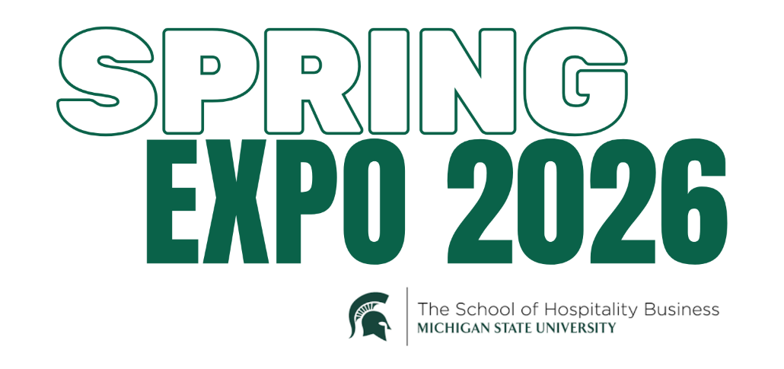

- Bay Harbor Yacht Club
- Compass Group USA
- Continental Services
- Country Club of Detroit
- Crowne Plaza Lansing
- Delaware North
- Detroit Zoological Society
- Elevated Homes & Hospitality
- Emergent Holdings
- Fairmont Chicago, Millennium Park
- Flexjet
- Four Seasons Hotels and Resorts
- Galleon Advisors
- Grand Traverse Resort and Spa
- Heirloom Hospitality
- HREC Investment Advisors
- Hyatt Hotels Corporation
- Inn at Bay Harbor
- J. Alexander's / Stoney River Restaurants

- Kimpton Hotels & Restaurants
- Lavender Hill Farm
- Let’s Play Sports Inc
- Levy Restaurants
- Little Harbor Club
- Marriott International
- Montage International Hotels and Resorts
- MSU Kellogg Hotel & Conference Center
- North Shore Country Club
- Otis Hotel Harbor Springs
- Peachtree Group
- Penn Entertainment
- Relais & Chateaux
- Resort at Paws Up
- The Homestead
- The Peninsula Chicago
- The Townsend Hotel
- Union Square Hospitality Group
- Zehnder’s of Frankenmuth

