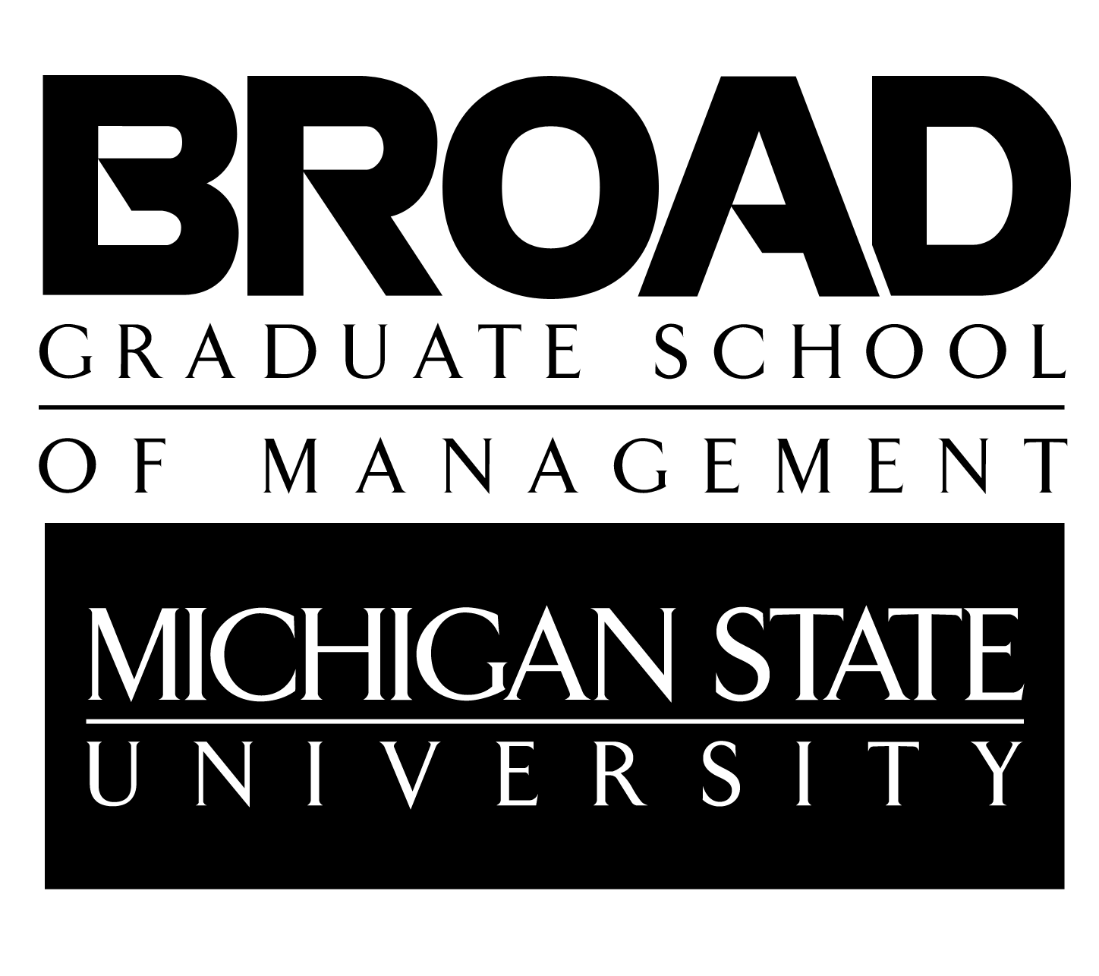
Master of Science in Accounting
Course Scheduling Guide
2021–2022

General Overview

OVERVIEW

- The M.S. in Accounting is a 30-credit degree program. More credits may be needed if prerequisite courses are required. Students must complete at least 12-15 accounting credits.
- Students are required to elect an accounting specialty option. Specialty options include Information Systems (IS), Public and Corporate Accounting (PCA), and Taxation (TAX).
- Students must complete at least (9) credits outside of accounting. Per accreditation standards, IS courses can also be considered as non-accounting classes.
- To schedule an appointment with your academic advisor, please use this link: (http://accounting.broad.msu.edu/welcome/ms/advising/).
- For students in the MS in Accounting program for Fall 2021, Accounting Analytics (ACC 827) will be required for all students to take as a required course.

DUAL-ENROLLMENT POLICY

- You must have a dual enrollment form on file.
- You must apply for graduation for your undergraduate degree.
- If you change a course or do not adhere to the dual-enrollment policy, it could result in classes not counting towards your M.S. degree.
- Contact the Director with any questions regarding dual enrollment.

OVERRIDE POLICY:

- You will need to apply for overrides in the following cases before enrollment begins:
  - If you did not complete your undergraduate degree at MSU.
  - If you did not complete the course prerequisites at MSU.
  - If you wish to enroll in any non-accounting courses (e.g. MKT, SCM, FI, MGT, GBL, etc.).
  - If the course is offered outside of the Broad College of Business. You will need to contact the specific department to get an override (EC 420 contact the Economics Department).
  - If you are a graduate student taking a 300- or 400- level course.
  - If you are dual enrolling and taking any 800-level course.
  - If any course is beyond the enrollment limit.

- Links for overrides:
- Accounting (ACC), Finance (FI), Supply chain management (SCM), Management (MGT), Marketing (MKT), General business/law (GBL) (https://uas.broad.msu.edu/advising-student-services/overrides/).
- Supply chain management (SCM) & Marketing (MKT) need to email directly, or we will forward the override ticket to broad.msc.inquiries@msu.edu.
- Management overrides need to be emailed directly to mgt@msu.edu.
- COM 875 is our course, and you should not have to apply for an override (unless you are dual enrolled or it is at the enrollment limit-contact the Director for further instructions). All courses that are outside the Broad Business College, you will need to contact that department for their override policy.

Specialty Option Requirements

Students must select one of the following three options and enroll in the required courses. Priority for courses will be given to those within the specialty option. All courses are 3 credits each.

- Information Systems (IS) Option
MSU undergraduate accounting majors: Pick (4) of these courses-ACC 822, ACC 823, ACC 824, ACC 825,
ACC 826
External accounting majors: ACC 821 and pick (3) of these courses- ACC 822, ACC 823, ACC 824, ACC 825, ACC 826
Required Course: COM 875 & ACC 827

- Public and Corporate Accounting (PCA) Option
Pick (4) of these courses-ACC 807, ACC 808, ACC 814, ACC 833, ACC 841, ACC 843, ACC 850
Required Courses: COM 875, FI 801, & ACC 827

- Taxation (TAX) Option
These courses- ACC 830, ACC 833, ACC 836, ACC 850
Required Courses: COM 875, FI 801, & ACC 827

SCHEDULING ADVICE

- Taxation (TAX) Option suggestions:
  - ACC 833 and 836 may be taken concurrently.

- Information Systems (IS) Option suggestions:
  - Only (4) of the (6) courses are required for this specialty.
  - For a solid technical core, the faculty recommends ACC 823, 825, & 826.
  - External accounting majors wanting to complete their M.S. in one year should take ACC 821 in the fall.

- For those wishing to take the CPA exam these classes are suggested for more in depth understanding of the accounting topics. They are not required to take the CPA Exam.
  - ACC 850: Accounting for Multiunit Enterprises
  - ACC 833: Federal Income Taxation of Corporations and Shareholders
  - ACC 808: Contemporary Financial Reporting Decisions
  - ACC 814: Advanced Auditing
  - ACC 308: Governmental & Not-for-Profit Accounting (1 credit)*
*Although credits at the 300-level cannot be counted toward the M.S. degree, having study in this subject is a requirement for CPA licensing in the State of Michigan. It is recommended that MSU undergraduates take this course in the last semester of their senior year.
COURSE OFFERINGS

Fall Semester
Course | Course Title | Prerequisite | TAX | IS | PCA
ACC 814 | Advanced Auditing | ACC 411 |  |  | X
ACC 821 | Enterprise Database Systems |  |  | X
ACC 822 | Information Systems Project Management |  |  | X
ACC 823 | Advanced Enterprise Database Systems |  |  | X
ACC 824 | Governance and Control of Enterprise Systems |  |  | X
ACC 827 | Accounting Analytics | ACC 321/821 & ACC 411 | X | X | X
ACC 830 | Tax Research | ACC 331 | X
ACC 843 | Value Chain Accounting and Analytics | ACC 341 and MKT 317 |  |  | X
ACC 850 | Accounting for Multiunit Enterprises | ACC 301 and ACC 331 | X |  | X
COM 875 | Communication Leadership Skills in Organizations |  | X | X | X
FI 801 | Managerial Finance | FI 311 | X |  | X

Spring Semester

Course | Course Title | Prerequisite | TAX | IS | PCA
ACC 807 | Financial Statement Analysis | ACC 301 |  |  | X
ACC 808 | Contemporary Financial Reporting Decisions | ACC 301 |  |  | X
ACC 822 | Information Systems Project Management |  |  | X
ACC 825 | Object-Oriented Business Information Systems  *Starting Spring 2019 | ACC 321 or ACC 821 |  | X
ACC 826 | Enterprise Information Systems |  |  | X
ACC 827 | Accounting Analytics | ACC 321/821 & ACC 411 | X | X | X
ACC 833 | Federal Income Taxation of Corporations and Shareholders | ACC 331 | X |  | X
ACC 836 | U.S. Taxation of Multinational Transactions | ACC 331 | X
ACC 841 | Strategic Management Controls Systems | ACC 341 and MGT 409 |  |  | X
COM 875 | Communication Leadership Skills in Organizations |  | X | X | X
FI 801 | Managerial Finance | FI 311 | X |  | X

Summer Semester
Course | Course Title | Prerequisite | TAX | IS | PCA
ACC 814 | Advanced Auditing |  |  |  | X
COM 875 | Communication Leadership Skills in Organizations |  | X | X | X

Electives

OVERVIEW

- Students are required to take at least nine (9) credits outside of accounting. Per accreditation standards, IS courses are not considered accounting.

- Students entering the M.S. Program without a previous degree in business may have to use their elective credits toward introductory courses in economics, finance, supply chain management, and marketing (FI 801, SCM 800, MKT 805).

- Students can take up to six (6) credits at the 400 level (upon approval from the MS in Accounting Director or Assistant Director).

- Presented below are the most common courses taken. The courses in bold are recommended by the faculty.

- Depending upon career interests and background, one may find courses of interest in other colleges/departments on campus and are free to look at other academic departments within the University for potential electives. You must get approval from the Director on all your electives to count towards the 30 credits that are not listed on the elective sheet or study plan.

- Please note: Departments often change semester offerings and course descriptions. For the most accurate and up to date information please check the Schedule of Courses at http://student.msu.edu/ and Description of Courses at http://www.reg.msu.edu/Courses/Search.asp.

COURSES
FS=Fall SS=Spring US=Summer

Accounting
Course | Course Name | Prereq. | Semester | Notes
ACC 493 | Internship |  | FS, SS, US | A limit of up to 3 credits will be allowed for the Internship class.

Business
Course | Course Name | Prereq. | Semester | Notes
BUS 491 | Special Topics: Business Internship |  | FS, SS, US | A limit of up to 3 credits will be allowed for the Internship class. (Section 730).

Communication
Course | Course Name | Prereq. | Semester | Notes
COM 875 | Communication Leadership Skills in Organizations |  | FS, SS, US | Required for all students. Does not require override unless dual enrolled or at enrollment limit.

Finance*
If you took FI 311 & 312 we will waive FI 801. Please be aware that students taking classes in the 800 level finance courses can only enroll in the sections that are 1.5 credits as indicated in the notes and you must enroll in both sections of that course such as FI 845/846. FI 801 & FI 857 are 3 credits.
Course | Course Name | Prereq. | Semester | Notes
FI 413 | Management of Financial Institutions | FI 311 | FS, SS
FI 451 | International Financial Management | FI 311 | FS, SS, US
FI 457 | Security Analysis | FI 312 or FI 801 | FS, SS, US
FI 473 | Debt and Money Markets | FI 312 or FI 801 | FS, SS
FI 478 | Investment Strategies and Speculative Markets | FI 312 or FI 801 | FS, SS | Not available to students with credit in FI 852
FI 801 | Managerial Finance | FI 311 | FS, SS, US | Not available to students with credit in FI 311 & 312
FI 845/846 | Financial Modeling & Simulation I & II | FI 312 or FI 801 | FS, SS | 1.5 credit for both classes
FI 850/851 | Introduction to Investments I &II | FI 801 | SS | 1.5 credit for both classes
FI 852/855 | Financial Derivatives I& II | FI 801 | SS | 1.5 credit for both classes
FI 853/854 | Debt and Money Instruments and Markets/Fixed Income Assets | FI 850/851 | FS | 1.5 credit for both classes
FI 857 | Security Analysis and Portfolio Management | FI 850/851 | FS, SS
FI 860/861 | Multinational Corp Finance/International Financial Markets | FI 801 | FS | 1.5 credit for both classes
FI 862/865 | Corporate Strategy Valuation/Corporate Real Options Valuation | FI 801 | SS | 1.5 credit for both classes
FI 869/870 | Entrepreneurial Finance Venture Capital/Venture Capital and Private Equity | FI 801 | SS | 1.5 credit for both classes
*Graduate level finance courses are in high demand by MBA students. They are advanced level courses and many MS students do not have the background in finance. Those with more experience in finance should talk with the Director or Assistant Director about taking the other 800 level courses.

General Business/Pre-Law
Course | Course Name | Prereq. | Semester | Notes
GBL 460 | International Law and Business |  | FS
GBL 467 | Emerging Enterprise Law | GBL 385 | FS
GBL 480 | Environmental Law and Sustainability for Business: From Local to Global (I) |  | FS
GBL 491 | Topics in Business Law | GBL 385 | SS

Management
Course | Course Name | Semester | Notes
MGT 804 | International Management | FS, SS | Limited enrollment
MGT 810 | Human Resource Management | FS, SS | Limited enrollment
MGT 811 | Fundamentals of HR Staffing | FS, SS | Limited enrollment
MGT 840 | Leadership | SS | Spring only

Marketing
Course | Course Name | Prereq. | Semester | Notes
MKT 805 | Marketing Management |  | FS, SS | Not available to MSU students with credit in MKT 300
MKT 860 | International Business |  | FS | 1.5 credit
MKT 862 | Global Marketing | MKT 805/MKT 300 | FS | 1.5 credit

Supply Chain Management
Course | Course Name | Prereq. | Semester | Notes
SCM 800 | Supply Chain Management |  | FS | Not available to MSU students with credit in SCM 303
SCM 833 | Decision Support Models | SCM 800/SCM 303 | FS | 1.5 credit
SCM 842 | Total Quality Management | SCM 800/SCM 303 | SS | 1.5 credit
COURSE DESCRIPTIONS
– Specialty Options

Information Systems (IS)
(MSU undergraduate accounting majors need 5 courses from list; non-MSU undergraduate majors need 6 courses from list)

ACC 821 Enterprise Database Systems (required for non-MSU undergraduate majors)
Management of information in business organizations. Conceptual modeling of transaction process systems, workflow systems and enterprise-wide networks of value-added activities. Integration of decision support and policy level systems with economic event processing systems. Evolution of accounting systems.

ACC 822 Information Systems Project Management
Management of information system projects. Modeling of business processes. Management of project scope, time and costs. Planning and control of projects. Program and portfolio management. Consulting issues for effective project management.

ACC 823 Advanced Enterprise Database Systems
Architecture of enterprise information. Semantic and syntactic modeling of enterprise economic phenomena, relational database technology and database design for business systems, business process analysis patterns and implementation compromises.

ACC 824 Governance and Control of Enterprise Systems
Governance and control of information technologies. Identification and valuation of key information and communication technologies, frameworks for assessing information system risk, information system auditing, and international standards for information technology governance and control.

ACC 825 Object-Oriented Business Information Systems
Analysis and design of object-oriented business systems. Unified modeling language descriptions of business phenomena and rules, object-oriented programming, use-case analysis and specifications, and XML tag sets for transactions and reporting.

ACC 826 Enterprise Information Systems
Analysis, design and use of enterprise systems. Importance of enterprise system fit and reengineering of the enterprise. Implementation risks and organizational returns. Use of enterprise software.

.

Public and Corporate Accounting
(Focus on public and corporate accounting practice)

ACC 807 Financial Statement Analysis
Concepts of financial analysis using U.S. and international accounting information. Cash-flow and earnings based models for business valuation, and supply of and demand for accounting information in financial markets.

ACC 808 Contemporary Financial Reporting Decisions
Framework for making professional judgments and decisions about accounting for contemporary financial reporting issues. Conceptual framework, standard setting, accounting for financial instruments, foreign subsidiaries, and hedging.

ACC 814 Advanced Auditing
Economic, regulatory and technology environments as it relates to auditing in the public and private sectors. Risk analysis, professional standards, audit evidence gathering and evaluations, accounting and auditing research and decision making.

ACC 833 Federal Income Taxation of Corporations and Shareholders
The Federal income taxation of corporations and shareholders resulting from operations, distributions, formations, liquidation, and reorganizations. Taxation of pass through entities.

ACC 841 Strategic Management Controls Systems
Management accounting concepts for strategic management and business unit-management. Performance measurement, planning and budgeting, and control system design.

ACC 843 Value Chain Accounting and Analytics
Management accounting for operational management. Advanced cost system design, costing for new product development, profitability of customer and supplier relations and cost of quality.

ACC 850 Accounting for Multi-Unit Enterprises
Financial reporting and tax issues related to business combinations and divestitures and the resulting consolidated reporting of the multi-unit enterprise's financial and tax information.

Taxation

ACC 830 Tax Research
Writing and presentation techniques of tax research. Tax practice and procedure, and partnership taxation.

ACC 833 Federal Income Taxation of Corporations and Shareholders
The Federal income taxation of corporations and shareholders resulting from operations, distributions, formations, liquidation, and reorganizations. Taxation of pass through entities.

ACC 836 U.S. Taxation of Multinational Transactions
Federal income taxation of transactions by U.S. persons outside the United States, and of investments by foreign persons in the U.S.

ACC 850 Accounting for Multiunit Enterprises
Financial reporting and tax issues related to business combinations and divestitures and the resulting consolidated reporting of the multi-unit enterprise's financial and tax information.
COURSE DESCRIPTIONS
– Electives
Accounting

ACC 493 Internship
Professional internship in public, industrial or governmental accounting under faculty supervision. Maximum credit earned is 3 credits.

ACC 827 Accounting Analytics
Help you develop an accounting data analytics mindset and learn how data analytics is used in different accounting related tasks, learn how to use the data visualization software.

Business

BUS 491 Special Topics in Business: Section 730 Internship
Supplemental and reflective methods to assist students in developing meaningful professional and career goals while participating in a business internship experience. Course is offered fully online through D2L and course must be taken concurrently with internship experience. Maximum credit earned is 3 credits.

Communication

COM 875 Communication Leadership Skills in Organizations
Theoretical and practical approaches to organizational communication and leadership. Communication and responsibility in a new era. Leadership self-assessment, leadership in action and managerial communication, and leadership accountability.

Finance

FI 413 Management of Financial Institutions
Management, decision-making and policy formulation for depository and non-depository financial institutions emphasizing commercial banking. Savings banks, credit unions and non-bank financial institutions including investment banks.

FI 451 International Financial Management
Financial management of multinational firms. Theoretical and applied aspects of international capital budgeting, capital structure, cash management, asset pricing, and risk management. Cross-cultural and ethical considerations.

FI 457 Security Analysis
Fundamental analysis of individual stocks. Discounted cash flow valuation, relative valuation, special situations. Management of a real-money stock portfolio, the Michigan State University Student Investment Fund.

FI 473 Debt and Money Markets
Role and nature of international debt and money markets. Corporate and government bond valuation, fixed income derivative instruments and bond portfolio management. Special role of "time" in debt and money markets.

FI 478 Investment Strategies and Speculative Markets
Pricing, trading strategies, hedging applications, and markets for forwards, futures, swaps, and options.

FI 801 Managerial Finance
Short-, intermediate- and long-term problems. Financial planning and control. Applications in domestic and international settings.

FI 845/846 Financial Modeling & Simulation I & II
Applications of financial theory through computer modeling. Financial forecasting, cash flow modeling, and valuation.

FI 850/851 Introduction to Investments I &II
Security risk and return concepts. Portfolio analysis and concepts of market efficiency. Equity investments, bonds, options, futures, and international securities.

FI 852/855 Financial Derivatives I& II
Theories of domestic and international financial markets and instruments. Effects of risk and maturity on prices. Arrangement of business and portfolio risk and returns with options and futures.

FI 853/854 Debt and Money Instruments and Markets/Fixed Income Assets
Fixed-income security markets. Valuation of instruments traded.

FI 857 Security Analysis & Portfolio Management
Fundamental analysis of individual stocks. Discounted cash flow valuation, relative valuation, and special situations. Management of student-run investment fund.

FI 860/861 Multinational Corp Finance/International Financial Markets
Cross-border capital budgeting, capital structure, cash management, corporate governance, foreign currency and Eurocurrency markets, and currency risk management.

FI 862/865 Corporate Strategy Valuation/Corporate Real Options Valuation
Financial background and practical application of discounted cash flow (DCF), residual income (RI), and real options analysis (ROA) helpful in valuing companies and making sound managerial decisions intended to create value and increase shareholders' wealth. Development of valuation models.

FI 869/870 Entrepreneurial Finance Venture Capital/Venture Capital and Private Equity
Financing of entrepreneurial startups, venture capital, and private equity. Valuations of entrepreneurial startups, structuring venture capital, and private equity deals and partnerships.

General Business/Pre-Law

GBL 460 International Law and Business
The impact of international law on business practices. Government regulation of international business.

GBL 467 Emerging Enterprise Law
In-depth analysis of the law for new ventures. Laws one must follow before, during, and after creation of a company.

GBL 480 Environmental Law and Sustainability for Business: From Local to Global (I)
Environmental law and sustainability for business from comparative as well as local, national, and international perspectives.

GBL 491 Topics in Business Law
Current and emerging issues in business law to supplement and enrich existing courses.
Management

MGT 804 International Management
Management challenges and roles in a multinational business. Strategic planning in global firms, managing people in international organizations, leadership, and the future of international management.

MGT 810 Human Resource Management for General Managers
Human resource management functions performed by all managers. Design, administration, and evaluation of human resource activities. Needs assessment, program implementation and evaluation, information management and decision support, and international human resource management.

MGT 811 Fundamentals of HR Staffing
Fundamentals of human resource staffing. Legal issues; measurement, reliability, and validity; job analysis; performance assessment; and recruitment.

MGT 840 Leadership (1-3 Credits)
Development of leadership abilities through readings and laboratory application.

Marketing

MKT 805 Marketing Management (not available to MSU students with credit in MKT 300)
Strategic and decision-making aspects of marketing functions. Analysis, coordination, execution of marketing programs. Development of strategies and tactics. Segmentation, marketing mix, market response modeling, and ethics in a global context.

MKT 860 International Business
Management of the firm in the multinational environment. Assessment of international modes of operations, markets, financial strategies, services, and resources. Competitive strategy.

MKT 862 Global Marketing
Marketing strategies for international expansion. Global marketing planning, market selection, timing, modes of entry, and the marketing activities necessary for global marketing expansion.

Supply Chain Management

SCM 800 Supply Chain Management (not available to MSU students with credit in SCM 303)
Fundamentals of materials and logistics management. Strategic impact of the transformation process in a global economy. Quality, inventory management, logistics strategy, customer service, international procurement, management of technology.

SCM 833 Decision Support Models (only 1.5 credits)
Analytical models to support decision making with specific supply chain focus. Topics include multiple regression, linear optimization, decisions under uncertainty, and forecasting.

SCM 842 Total Quality Management (only 1.5 credits)
Total quality management principles and practices, tools and techniques, implementation of continuous quality improvement programs, links to manufacturing and competitive strategies. Six Sigma and statistical quality control

